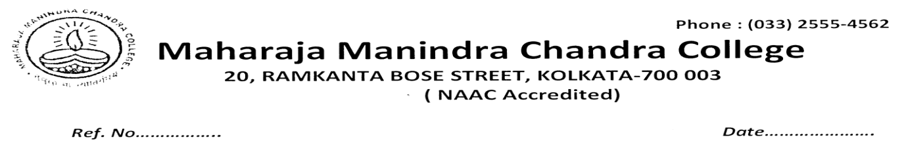
Resolution of the Special Meeting of Anti Ragging Sub-Committee (held on 29/05/2023)

In the special meeting of the Anti Ragging Sub-Committee conducted on 29/05/2023 at 8 pm via Google meet platform the resolutions taken against the agenda were:
AGENDA 1: To discuss/report the cases of ragging, if any, since the last meeting held on 15.9.2021 through the end of the session 2021-2022 and beginning of the academic session 2022 till date
RESOLUTION: The convener of the committee Dr. Rupa Bal reported that no cases of ragging of any kind were reported to the Committee or to any of its members since the last meeting held, and especially after the regular off line classes started after the Covid 19 Lockdown till date. Therefore, no meeting of the Cell was convened during that period.
This special meeting is conducted for the annual reporting purpose.
- Misc. Nothing discussed.

Members Present : 1. Dr. Rupa Bal(Convenor)
2 Dr. Antara Mitra Dutta
3. Ms. Rita Dutta
4. Mr. Souvik Basu

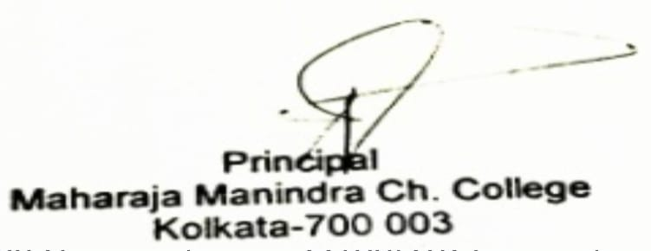

Dated. 29/05/23

